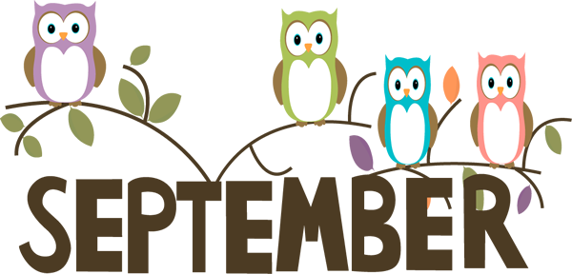



5

th

Grade

Newsletter

**Sneak peek at this week:**

**ELA:** This week we will continue our first guidebook unit. Work will be on Google Classroom, LearnZillion, and on paper. We are going to focus on responding to a prompt.

HW: Read every night for 20 minutes. Complete all classwork.

**Math:** Adding and Subtracting decimals.

Begin multiplication of decimals.

*HW: Continue to study multiplication facts.*

*Nightly problem sets.*

**Science:** Continuing discussion on Matter and it’s interactions. We will discuss changes and properties of matter.

*HW: complete any unfinished work*

*Study with notebook nightly.*

**Social Studies:** Continue to work on labeling continents and oceans! We need to know Geography!

Please encourage your child to read at home each night. Have them review skills covered in class.

*Subject to change

***\*Please sign up for REMIND 101 for* each *class, if you have not already done so: text “@ehall18”; “@dducote18”; and “@mssaaro” to 81010.***

***\*Permission forms for field trips will be sent home this week. We have TWO trips the first week of October.***

***\*Sign your child’s conduct each day.***

*Subject to change

**9/19:** Early Dismissal @12:45

**10/1:** Field Trip to Southeast Middle.

**10/4:** Field Trip to McKinley Middle.

**10/5:** Parent/Teacher Conferences

**(No School for kids)**

**10/8: Fall Break No School**

**Subject to Change



**Sept. 17-21, 2018**

**School Website:**

**wedgewoodelem.weebly.com**

**5**

**th**

**Grade Teachers**

Mrs. Aaron- Math

Ms. Hall- ELA

Ms. Ducote- Science & Social Studies

[This Phot](http://bowersarthistory.wikispaces.com/Chevron)

[o](http://bowersarthistory.wikispaces.com/Chevron)

by Unknown Author is licensed under

[CC B](https://creativecommons.org/licenses/by-sa/3.0/)

[Y](https://creativecommons.org/licenses/by-sa/3.0/)

[-](https://creativecommons.org/licenses/by-sa/3.0/)

[S](https://creativecommons.org/licenses/by-sa/3.0/)

[A](https://creativecommons.org/licenses/by-sa/3.0/)